**Title : Laptop Request Catalog Item Servicenow**

**Team ID: NM2025TMID18278**

**Team members:**

**TEAM LEADER - POOVARASAN. S**

**TEAM MEMBER – RAKESHKUMAR.V.R**

**TEAM MEMBER – SANJAY.K**

**TEAM MEMBER – RAMPRASAD.M**

**Table of Contents**

|  |  |  |
| --- | --- | --- |
| **S.no** | **Title** | **Page.no** |
| 1 | Introduction | 1 |
|  | **Update set** |  |
| 2 | Create Local Update set | 2 |
|  | **Service Catalog Item** |  |
| 3 | Create Service Catalog Item | 4 |
| 4 | Add variables | 6 |
|  | **UI Policy** |  |
| 5 | Create Catalog UI policies | 12 |
|  | **UI Action** |  |
| 6 | Create UI action | 15 |
|  | **Export Update set** |  |
| 7 | Exporting changes to another instances | 17 |
|  | **Login to another Instance** |  |
| 8 | Retrieving the update set | 19 |
|  | **Testing** |  |
| 9 | Test Catalog Item | 22 |
| 10 | **Conclusion** | 25 |

**Introduction :**

In modern organizations, the **laptop request process** is one of the most frequently used IT services, as laptops are essential for employees to perform daily tasks. However, in many companies, the process of requesting and provisioning laptops is still handled manually through emails, paperwork, or verbal communication. This traditional method is often **time-consuming, prone to errors, and inefficient**, which negatively affects both employee productivity and IT service delivery.

A major challenge lies in the **lack of standardization** in request submissions. Employees often provide incomplete or inconsistent details such as the laptop model, justification, or purpose of use. This forces IT teams to spend additional time clarifying missing information, resulting in delays. Furthermore, the **approval process is unstructured**, as managers may overlook or delay approvals due to email overload, and in some cases, unauthorized requests get approved, leading to unnecessary costs for the organization.

The IT support team also faces **difficulties in tracking and managing requests**. Without a centralized system, IT staff struggle to maintain accurate records of pending, approved, or rejected requests. This lack of visibility slows down fulfillment and creates accountability issues when evaluating service delivery performance. At the same time, employees have **no transparency** once their request is submitted. They are often left in the dark about the progress of their request and must repeatedly follow up with managers or IT staff, which wastes valuable time and causes frustration.

These combined challenges lead to **delays, miscommunication, and inefficiencies** in fulfilling laptop requests. For new hires, the delay can directly impact onboarding and prevent them from starting work on time, while for existing employees, late replacements or upgrades can hinder productivity. Therefore, there is a strong need for an **automated, structured, and transparent request process**. Implementing a Laptop Request Catalog Item in **ServiceNow** would solve these inefficiencies by providing a digital platform for requests, a clear approval mechanism for managers, and centralized tracking for IT staff. This solution ensures faster delivery, improved accountability, and a better overall experience for employees.

**Update set :**

**Create Local Update set:**

First open “**developer.servicenow.com**” and request an instance

After creation, click “**Start Building**” button and open the instance.

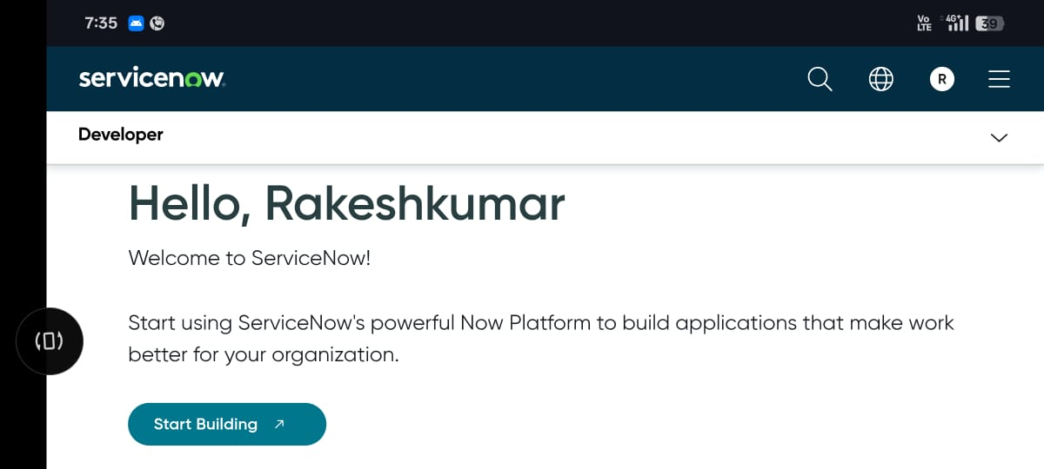

Click on “**All**” then search for "**Update Sets**".

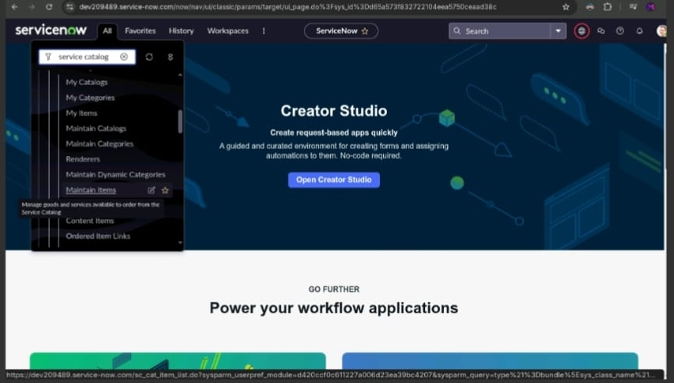

Under System Update Sets, select **Local Update Sets**.

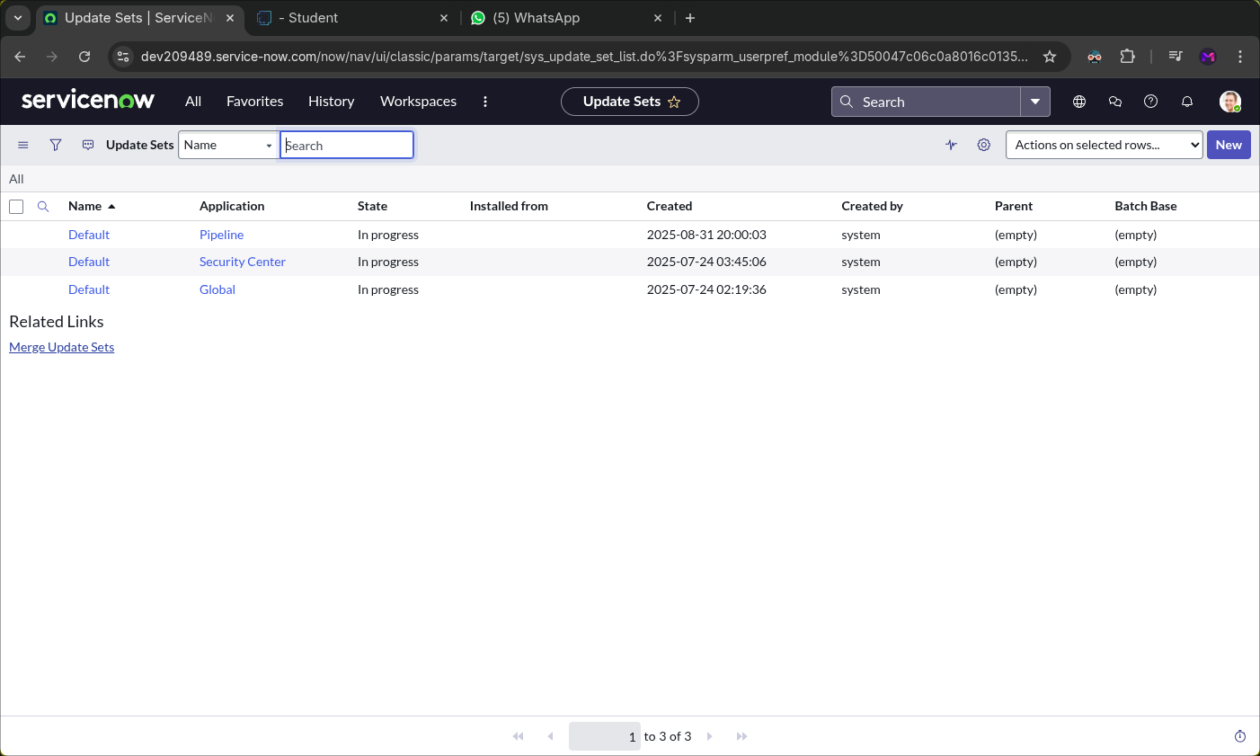

After selecting “**Local Update set**” the above page will open.

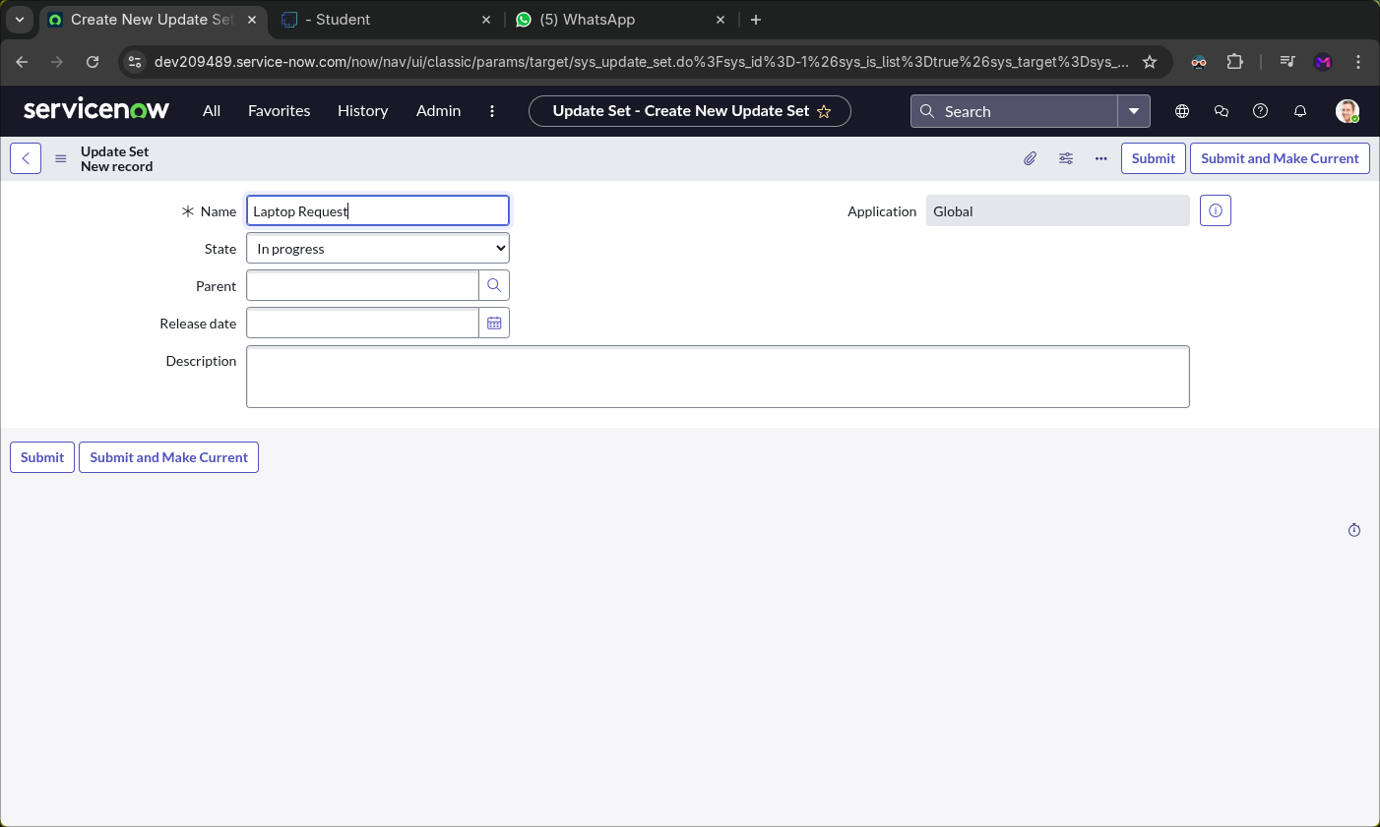In that page click “**New**” in top left corner

Enter the required details and name the update set **“Laptop Request”**.

Click the **Submit** on right corner and then choose **Make Current**.

**Service Catalog Item**

**Create Service Catalog Item:**

Click on “**All**” then search for "**service catalog**".

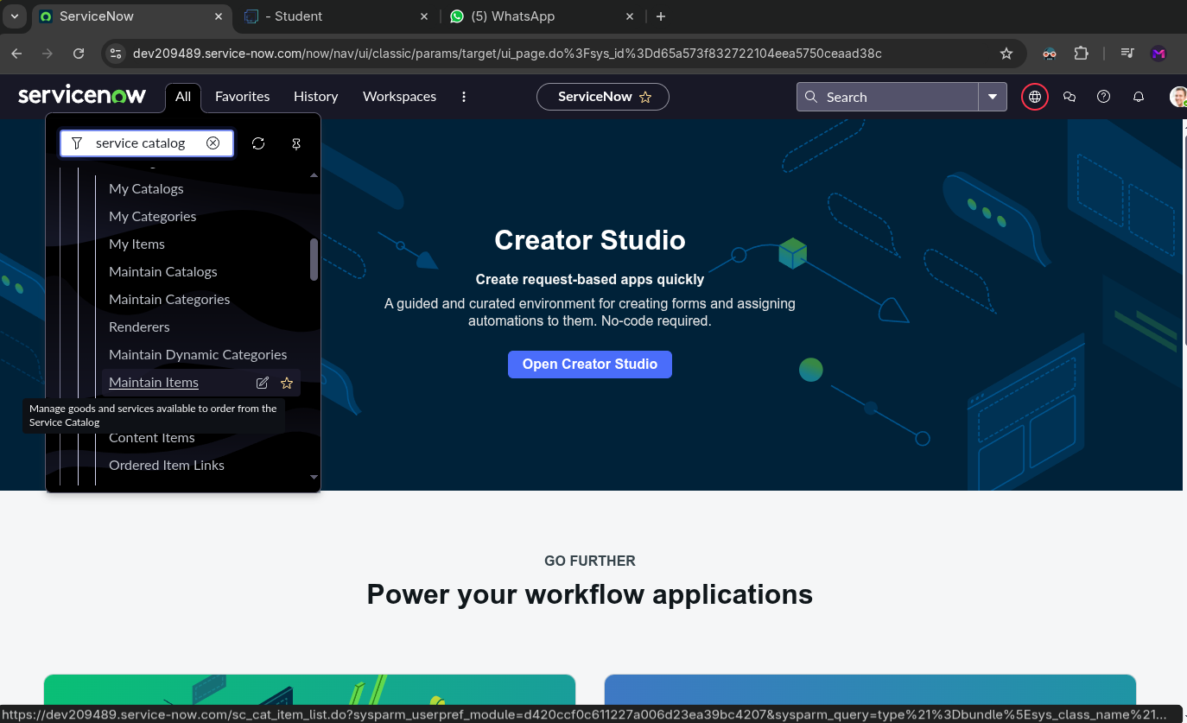Under **Catalog Definitions**, select **Maintain Items**.

If you do the above step, the below window will open.

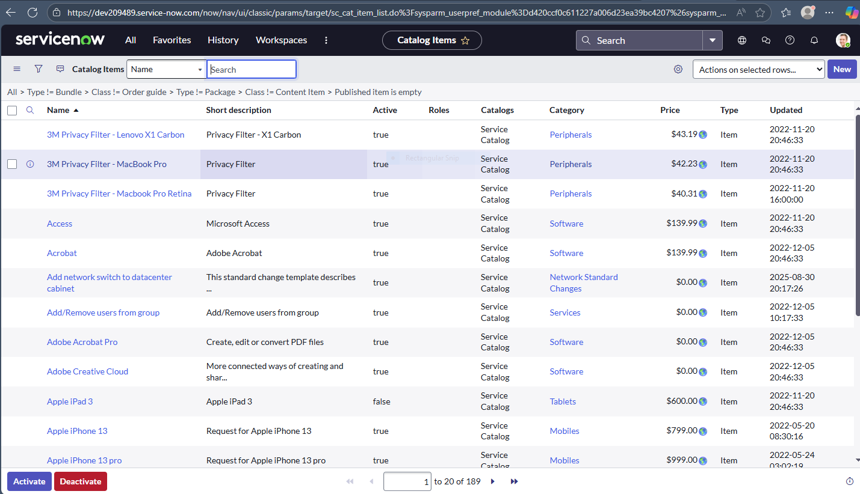

Click “**New**” in the top right corner of the opened page

If you do that, a new page will open like in the below picture.

In that page do the following steps

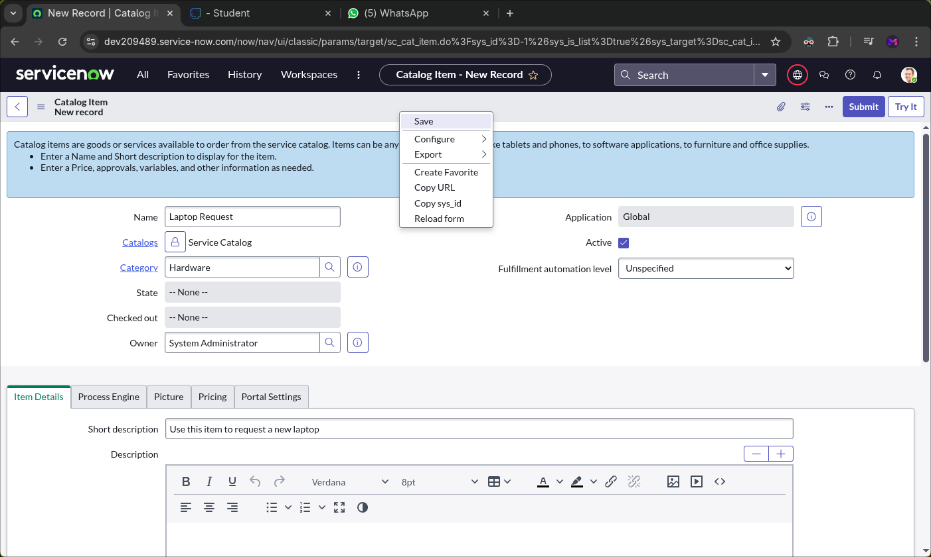

Enter the following details to create a new catalog item:

* **Name**: Laptop Request
* **Catalog**: Service Catalog
* **Category**: Hardware
* **Short Description**: Use this item to request a new laptop

Once all fields are completed, click **Save**.

**Add variables:**

After saving the catalog item form, scroll down to the **Variables** section in the related list.

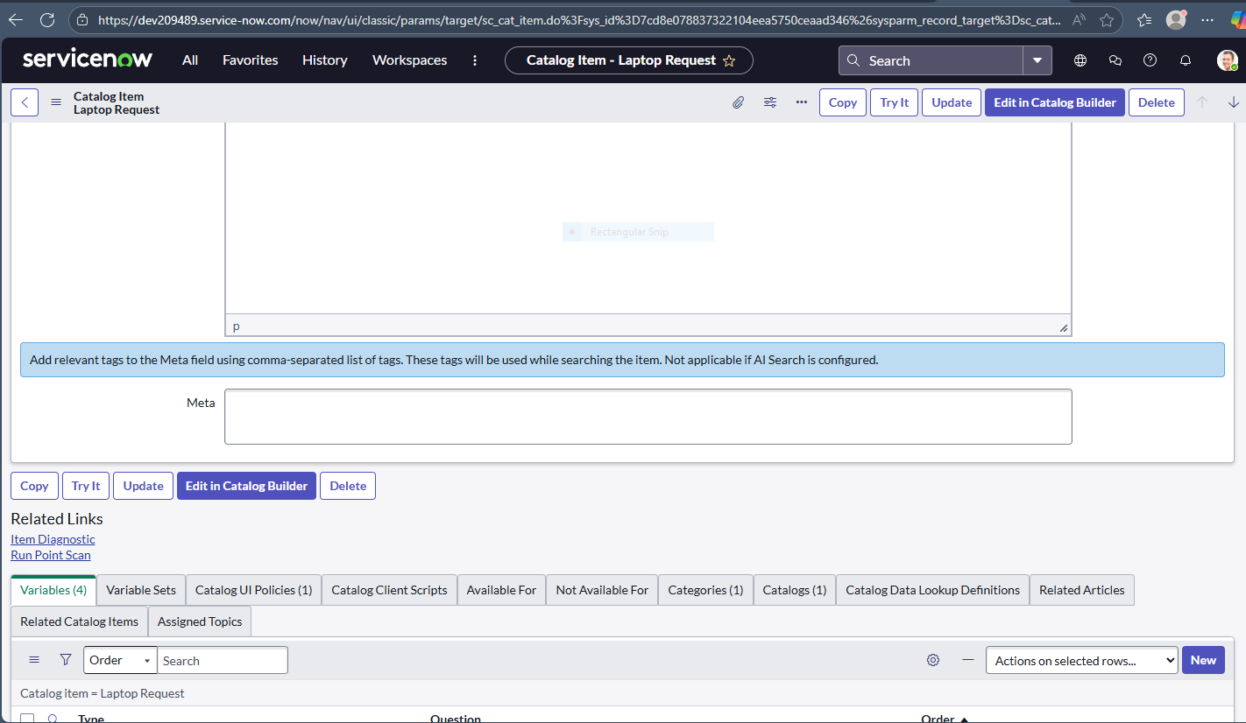That will look like the below picture.

Click “**New**” bottom right corner

After that below page will open.

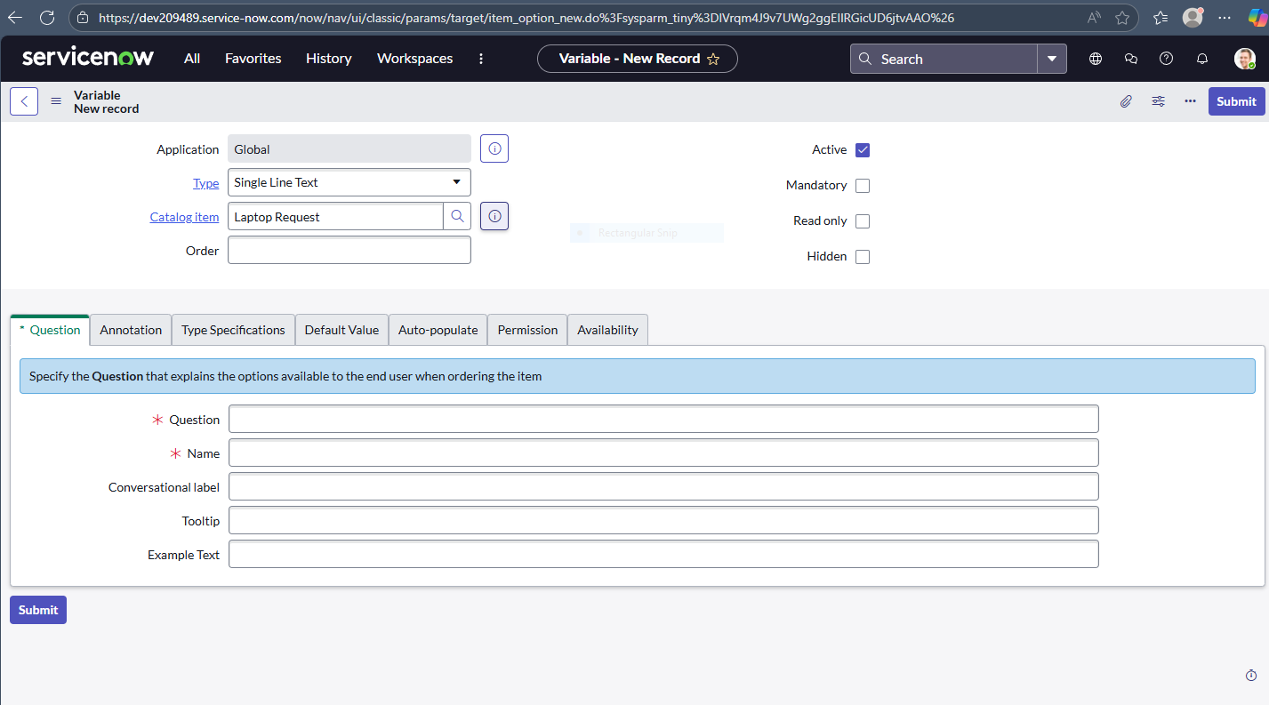

In that form enter these details:

* **Question**: Laptop Model
* **Type**: Single Line Text
* **Name**: laptop_model
* **Order**: 100

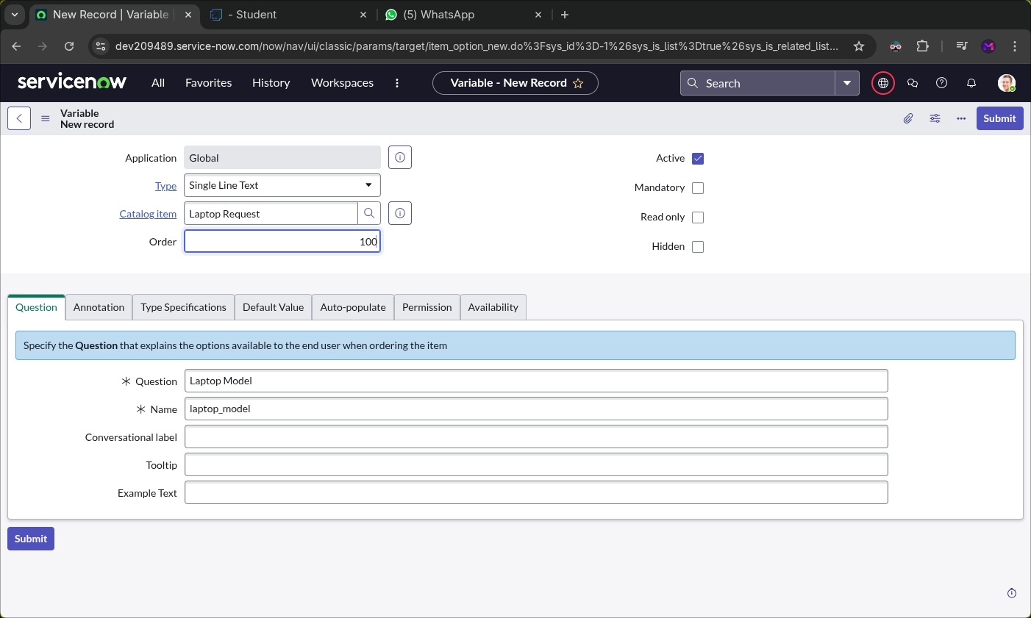

Click **Submit** to save the variable.

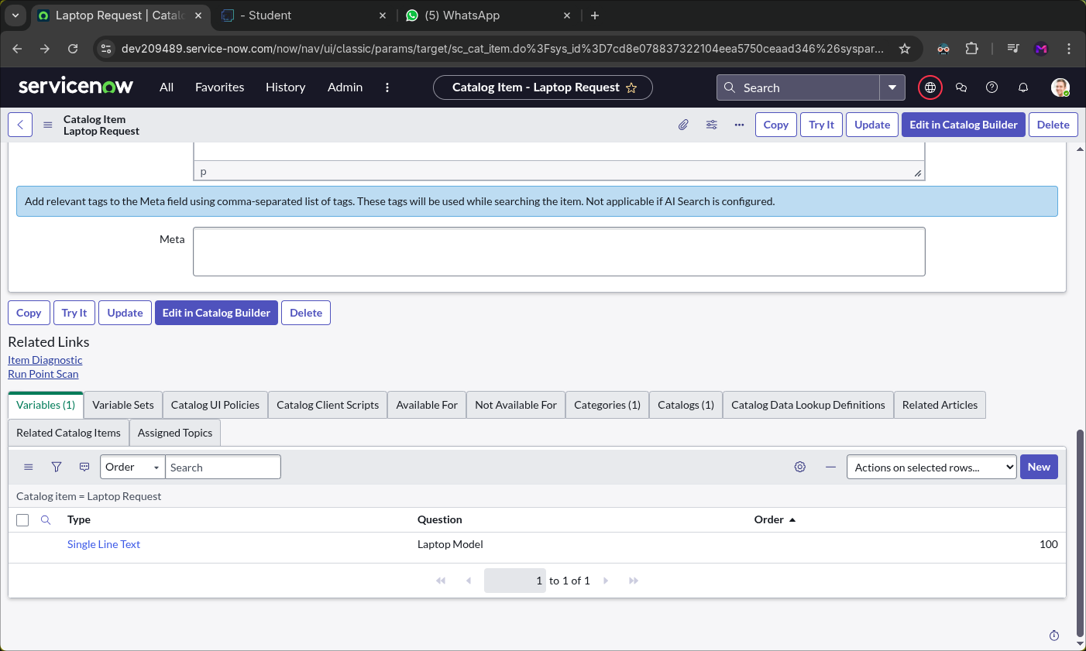

Click again “**New**” and add these 2nd details:

* **Question: Justification**
* **Type: Multi Line Text**
* **Name: justification**
* **Order: 200**

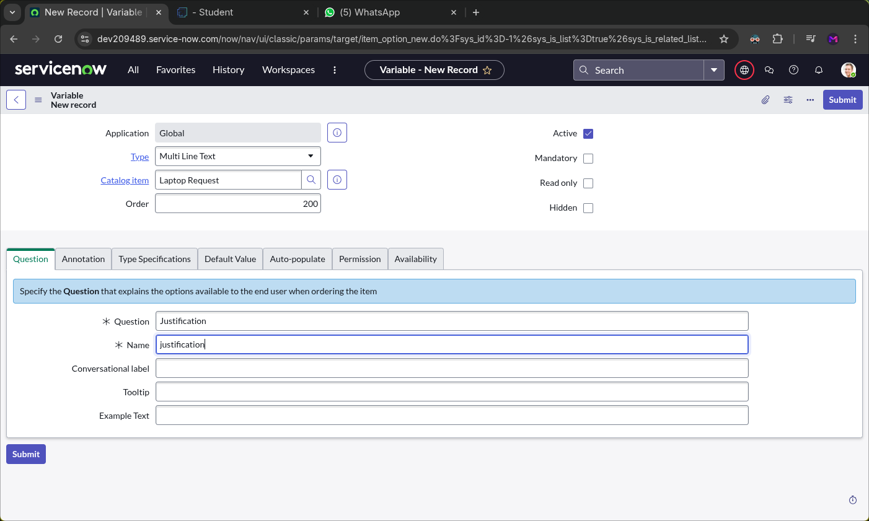

Click **Submit** to save the variable.

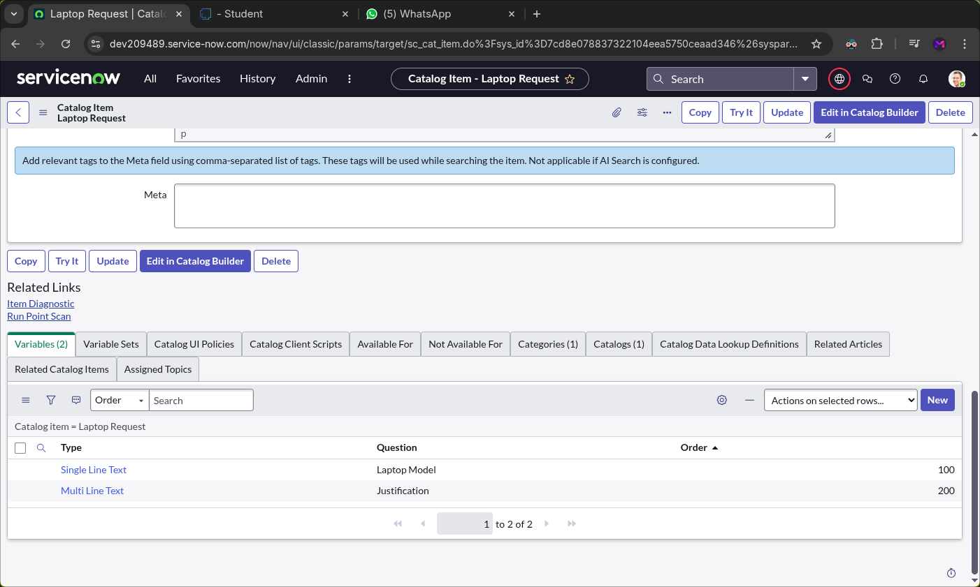

Click again “**New**” and add these 3rd details:

* **Question: Additional Accessories**
* **Type: Checkbox**
* **Name: additional_accessories**
* **Order: 300**

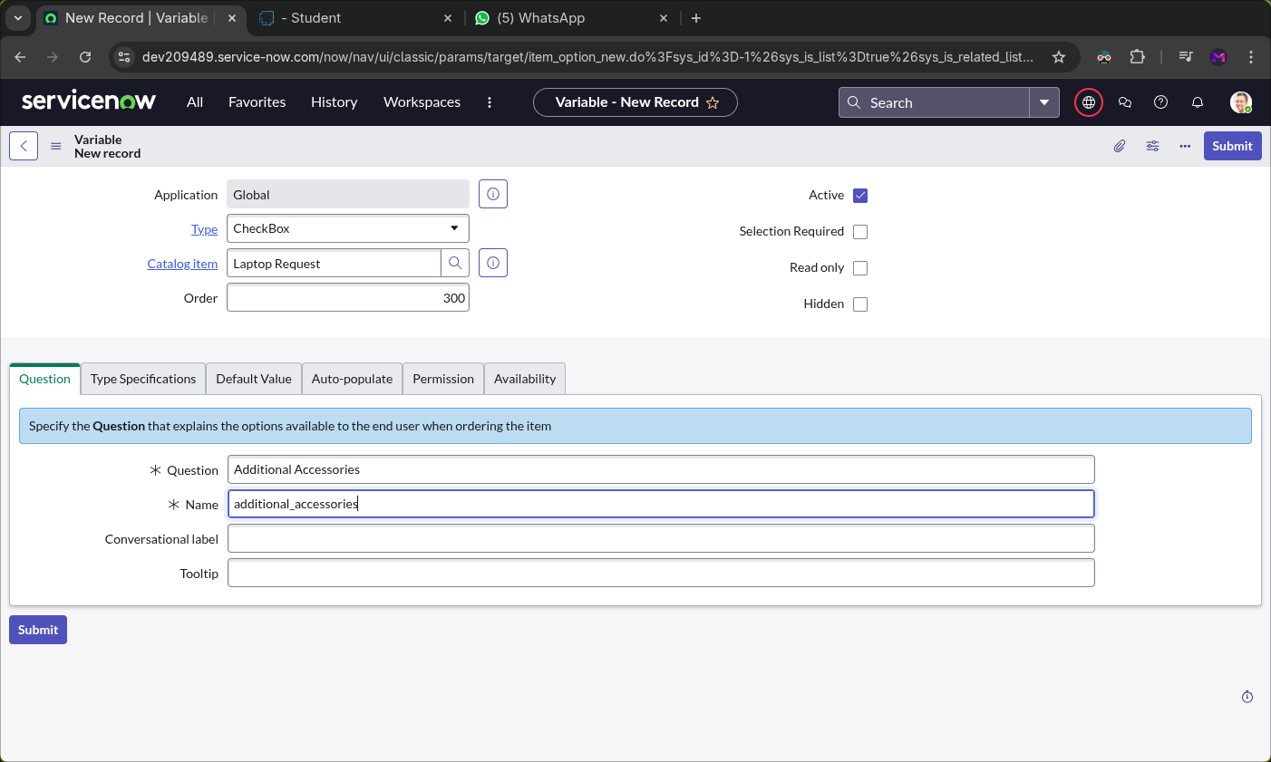

Click **Submit** to save the variable.

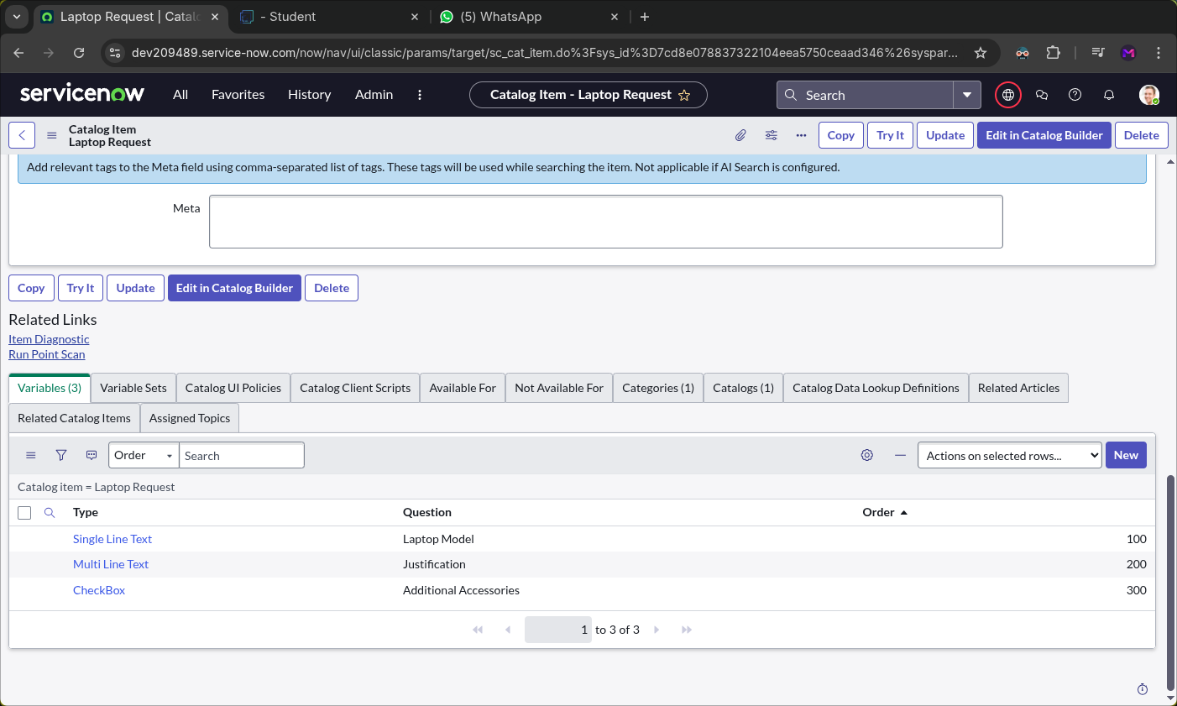

Click again “**New**” and add these 4th details:

* **Question: Accessories Details**
* **Type: Multi Line Text**
* **Name: accessories_details**
* 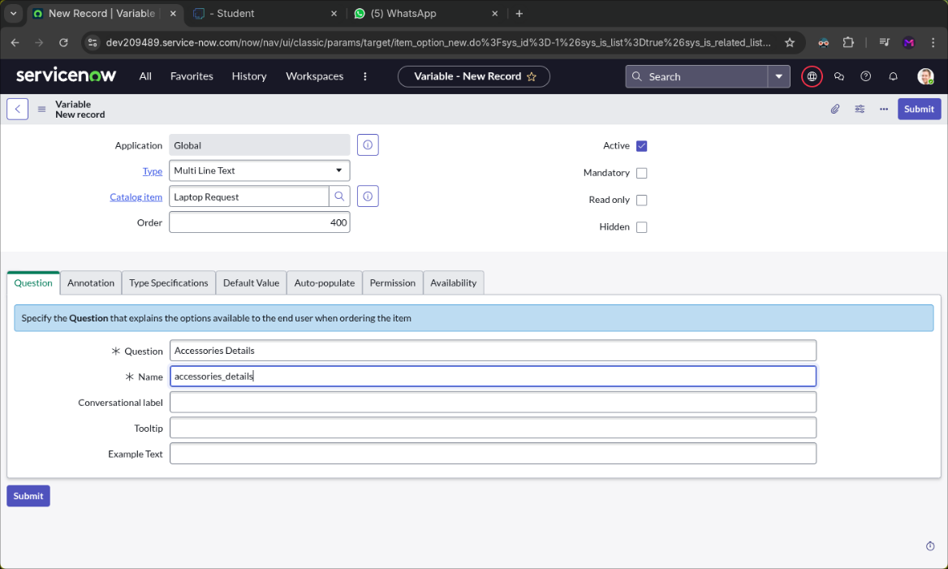**Order: 400**

Click **Submit** to save the variable.

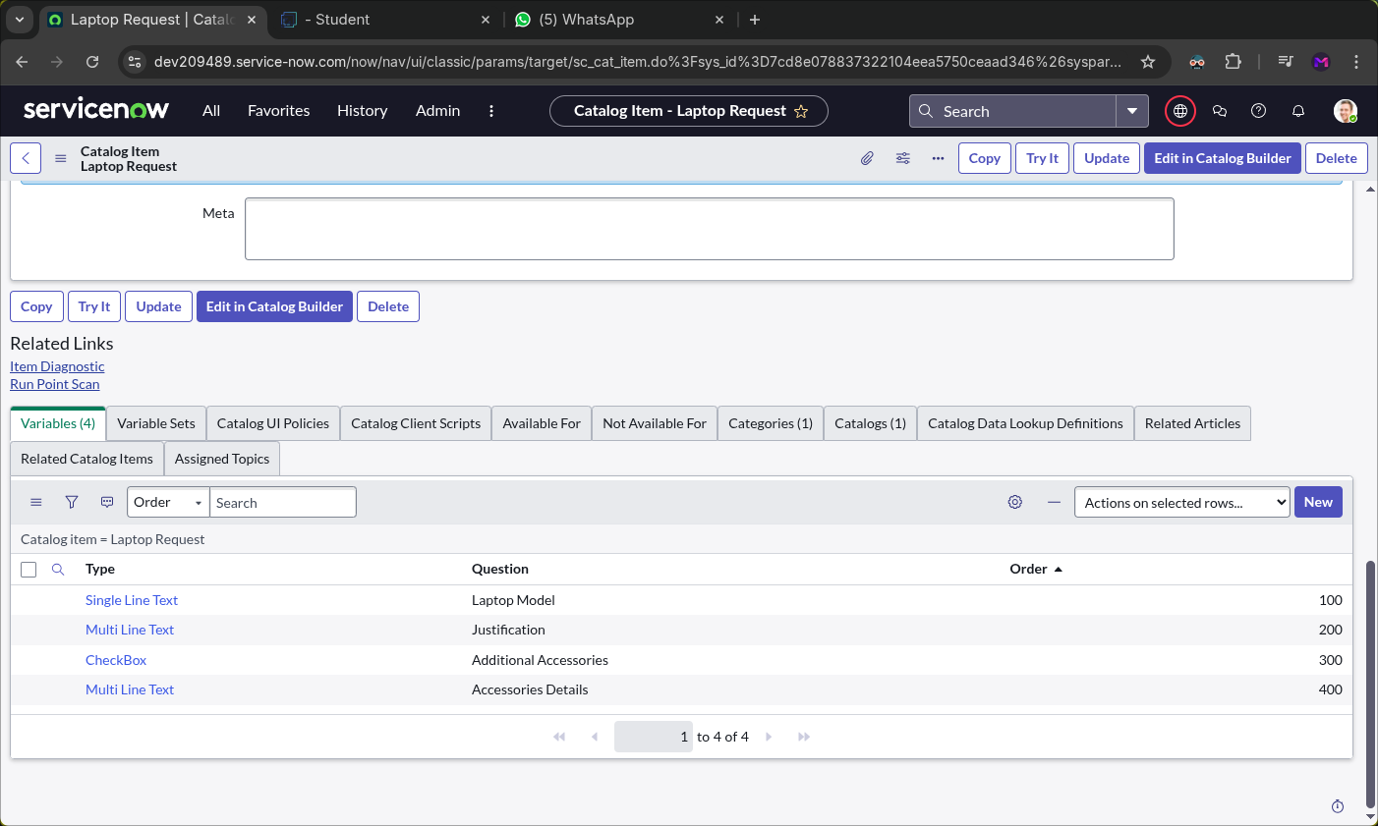

After adding all of these, make sure to save the form.

To view demo of this, click “**Try It**” of the top right corner.

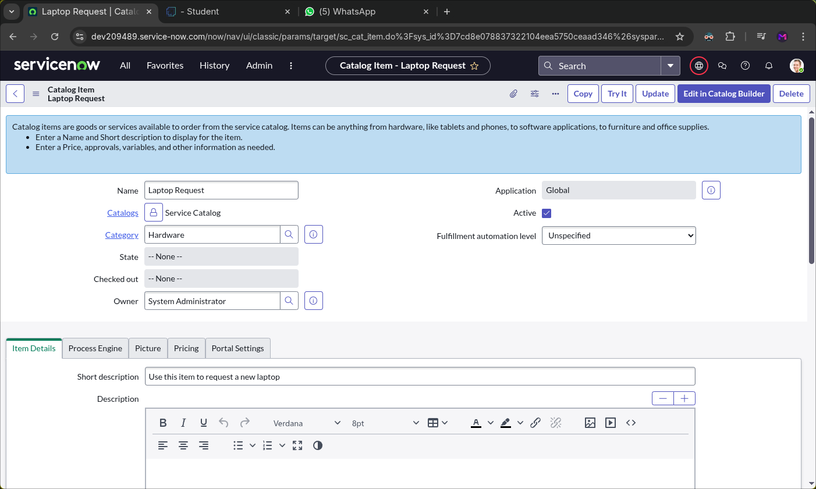

The demo will look, like this

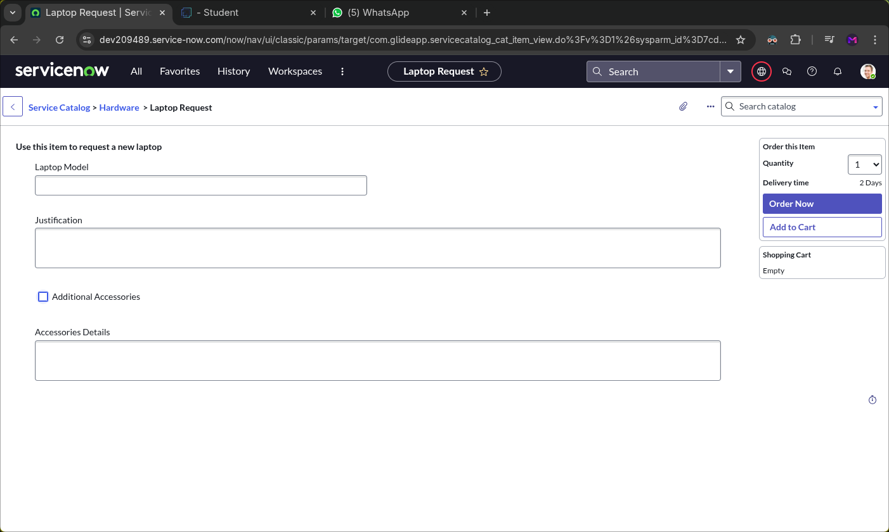

**UI Policy**

**Create Catalog UI policies:**

Navigate to **All → search for Service Catalog**.

Under **Catalog Definitions**, select **Maintain Items**.

Search for the previously created item **“Laptop Request”**.

Open the item, then scroll down to the **Catalog UI Policies** related list.

Click **New** to create a new UI policy.

Enter the following details:

* **Short Description**: Show Accessories Details
* **Catalog Condition (When to Apply)**:
  + **Field**: additional_accessories
  + **Operator**: is
  + **Value**: true

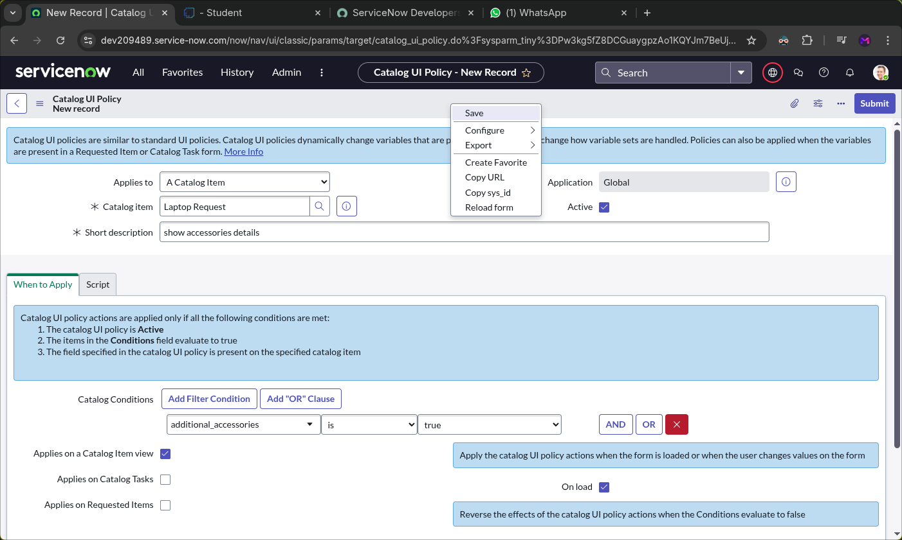

Click **Save** (do not click **Submit**).

Scroll down and open the **Catalog UI Policy Actions** related list.

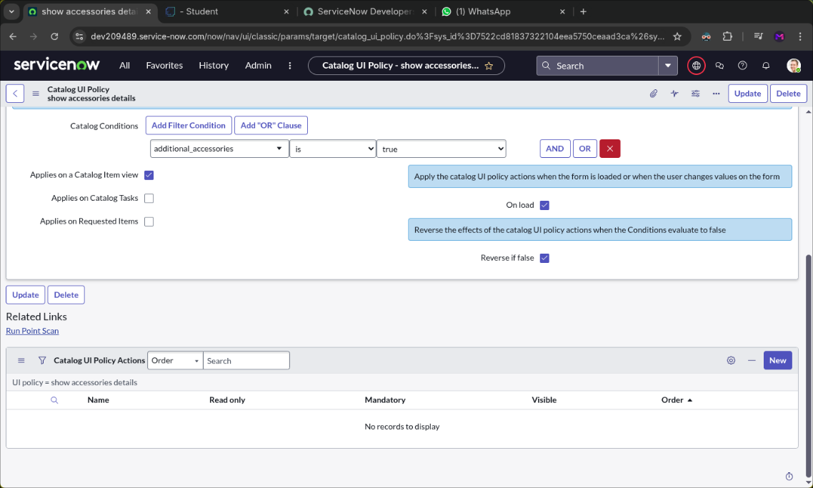Click **New** to create a new action.

A new page will open and, in that page, do the following

Configure the action with the following details:

* **Variable Name**: accessories_details
* **Order**: 100
* **Mandatory**: True
* 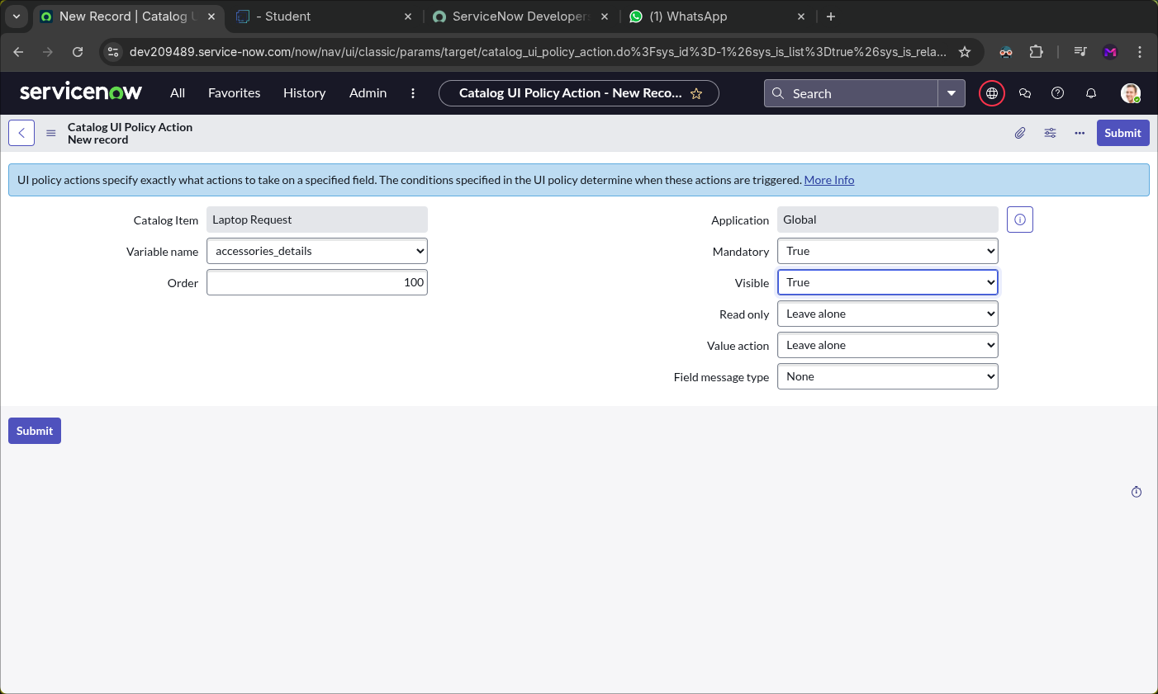**Visible**: True

You can see the demo of it

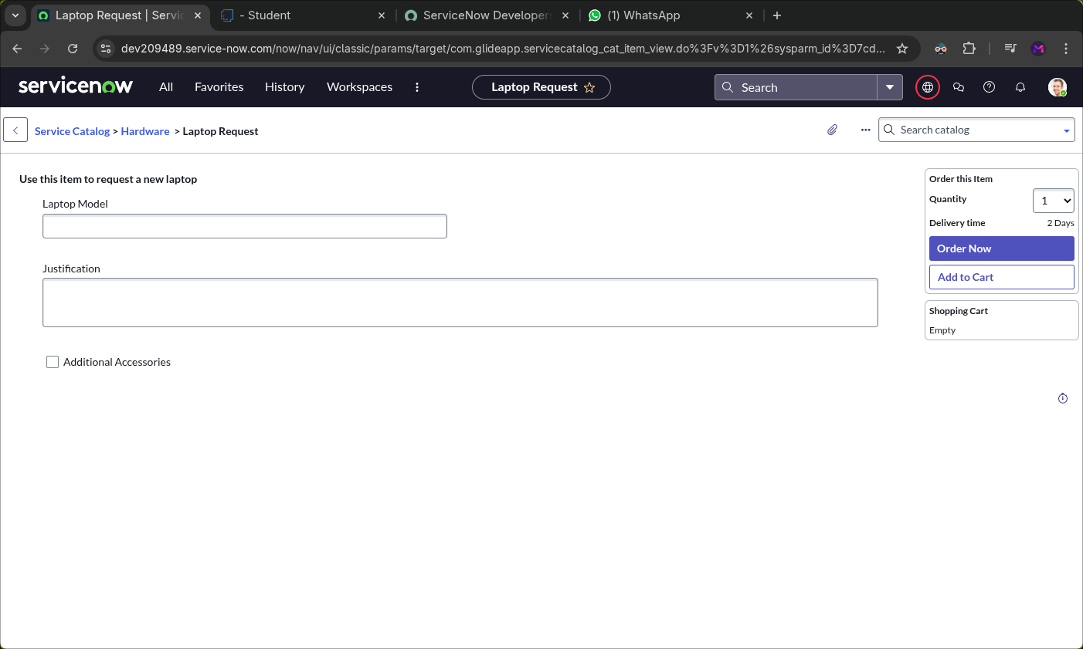

After clicking “**Additional Accessories**” it will look like below image:

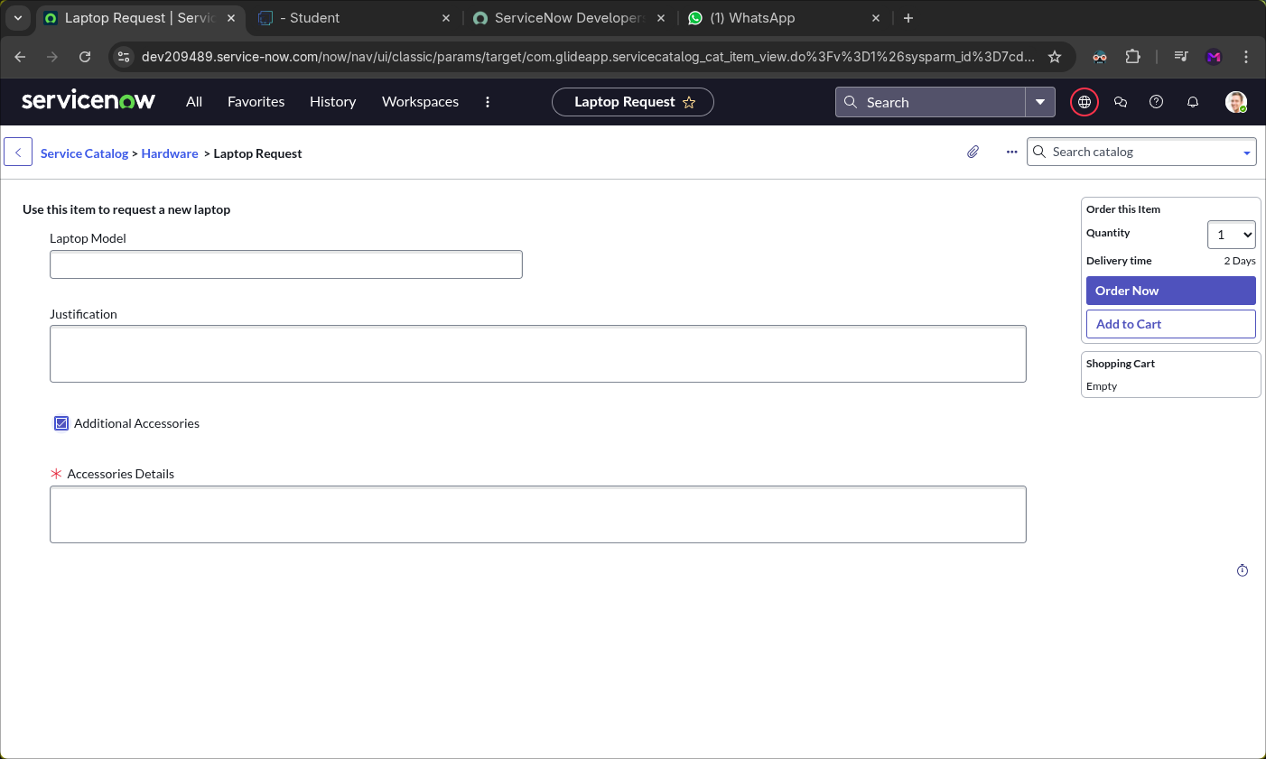

**UI Action**

**Create UI action:**

Go to **All → search for “UI Actions”**.

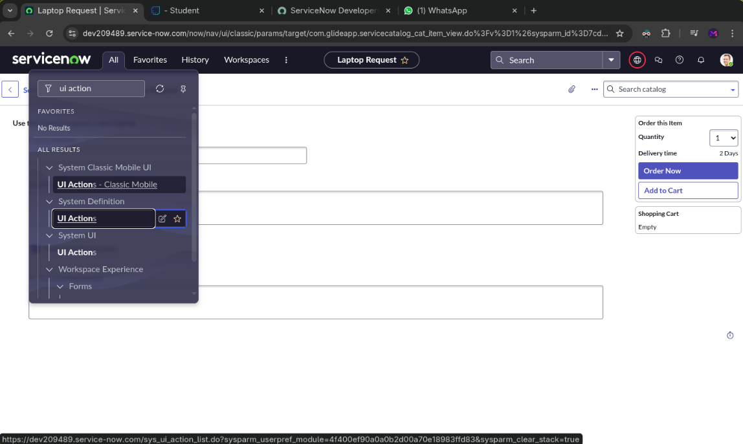Under **System Definition**, select **UI Actions**.

After navigating to that page, it will look like the below image.

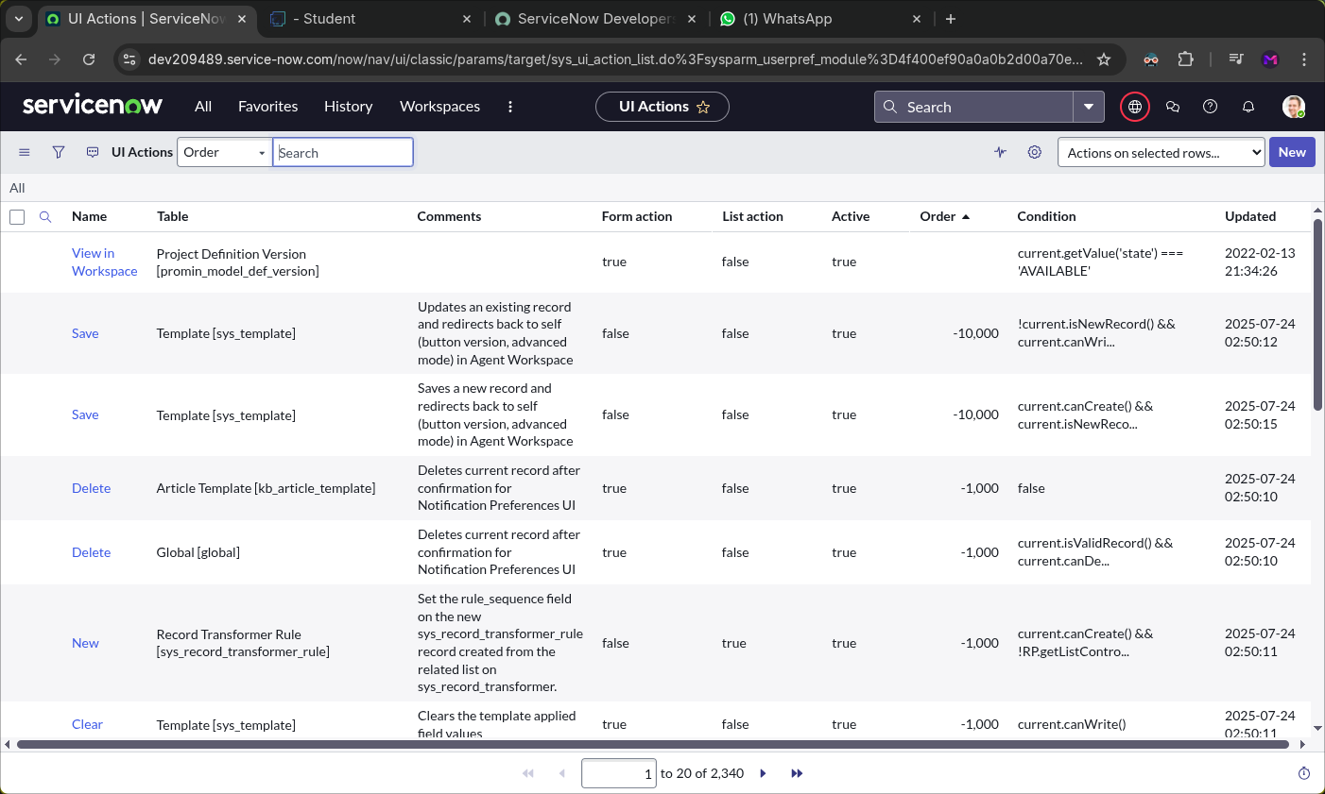

Click **New** to create a new UI Action.

Enter the following details:

* **Table**: Shopping Cart (sc_cart)
* **Order**: 100
* **Action Name**: Reset form
* **Client**: Checked

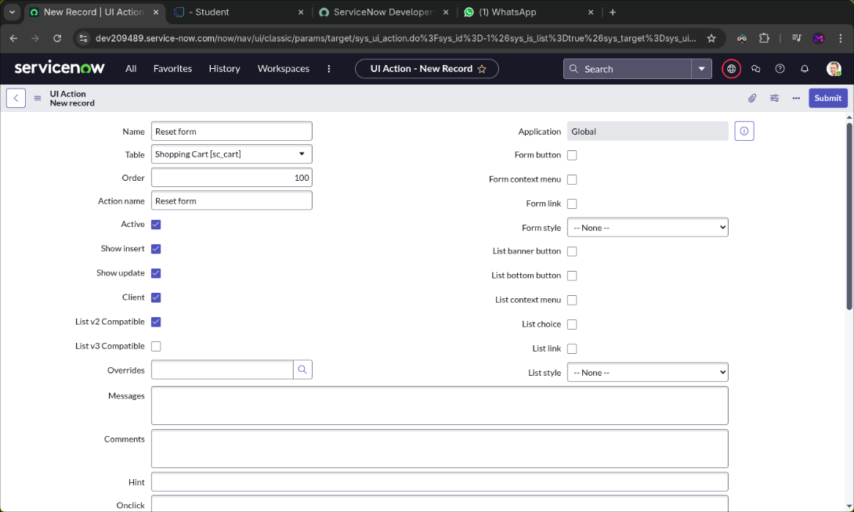

Add the following script and click “**Save**”:

**function resetForm() {**

**g_form.clearForm(); // Clears all fields in the form**

**alert("The form has been reset.");**

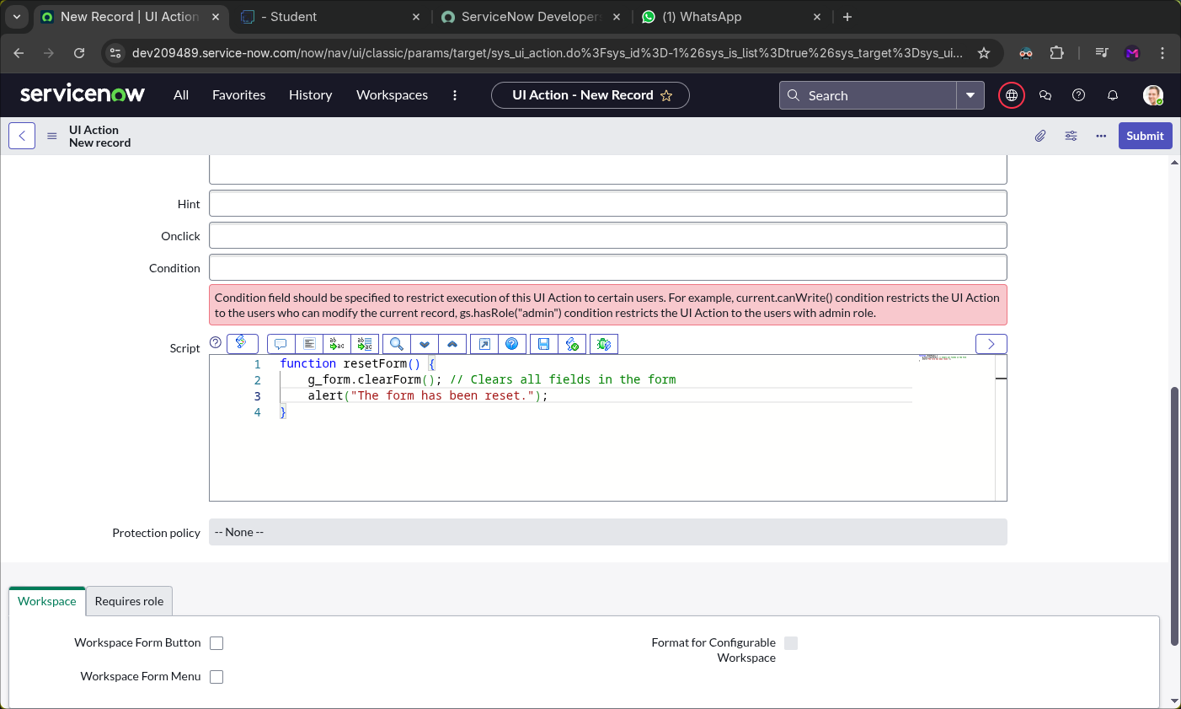**}**

**Export Update set**

**Exporting changes to another instances:**

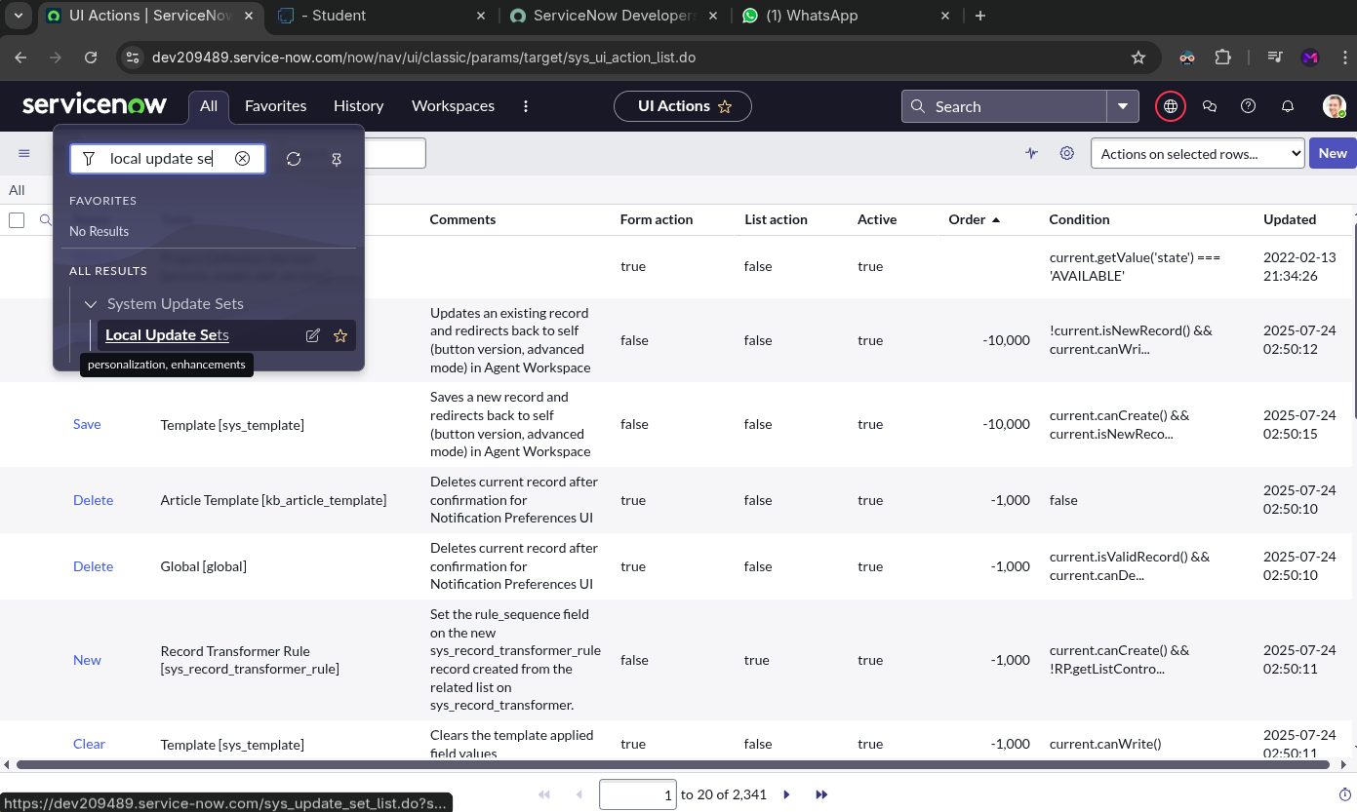Navigate to **All → search for Update Sets** and **select Local Update Sets**.

Open the previously created update set **“Laptop Request Project”**.

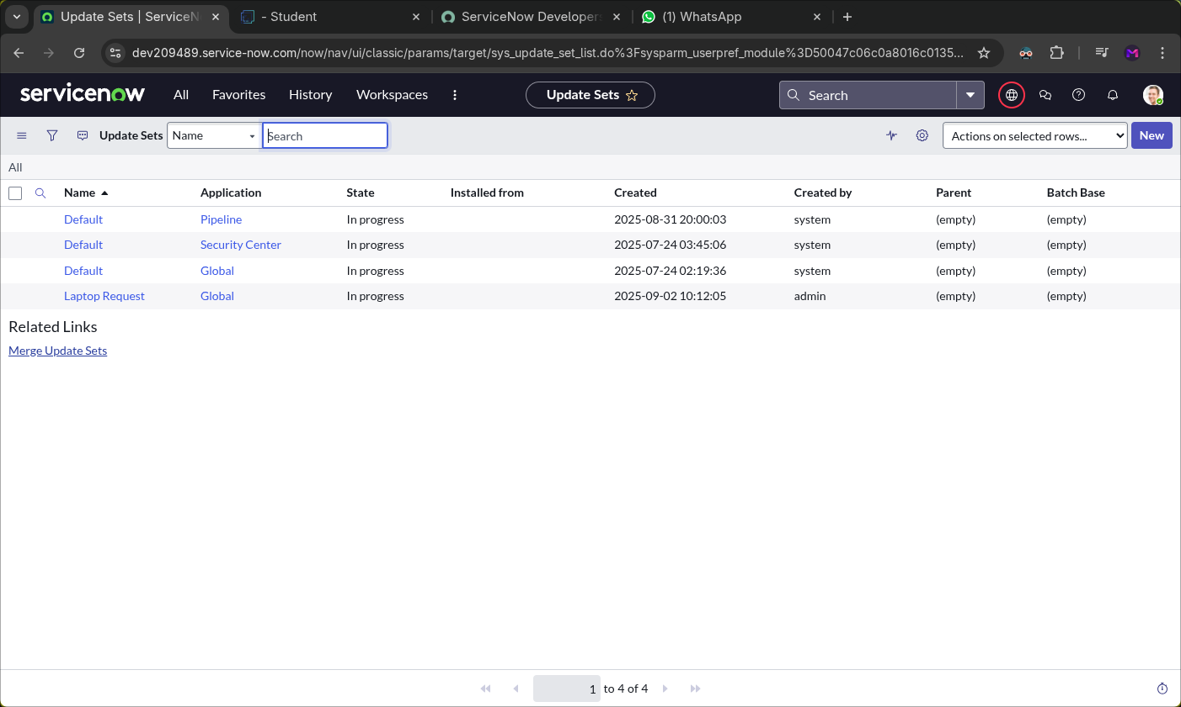

Change the **State** to **Complete**.

In the **Updates** related list, you can view all the changes captured under this update set.

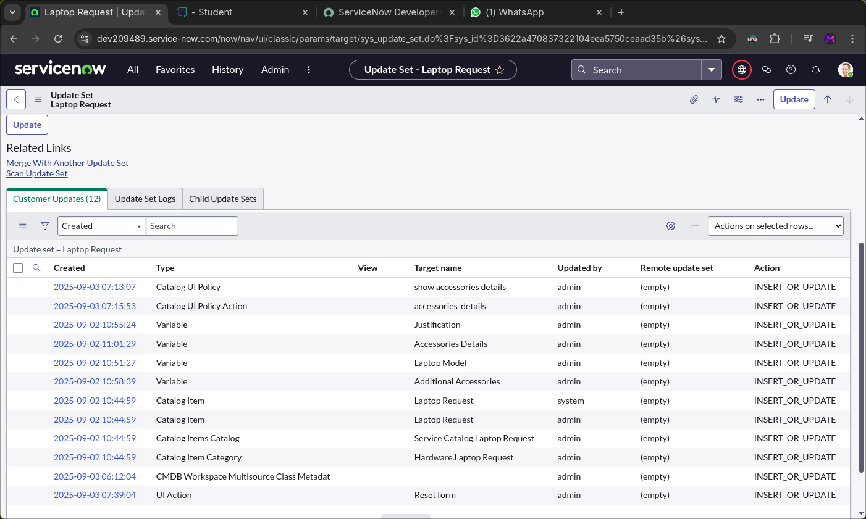

Click **Export to XML** to download the update set as a file.

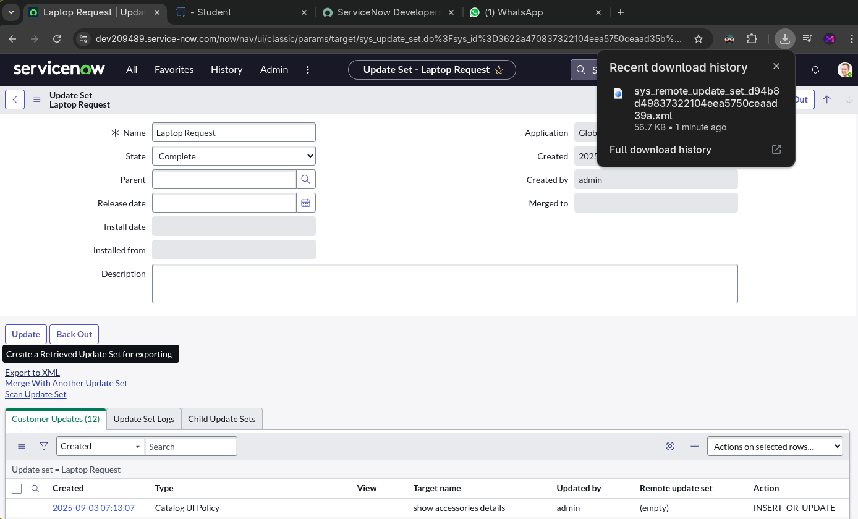

**Login to another Instance**

**Retrieving the update set:**

Open another ServiceNow instance with friend’s login

Navigate to **All → search for Update Sets**.

Under **System Update Sets**, select **Retrieved Update Sets**.

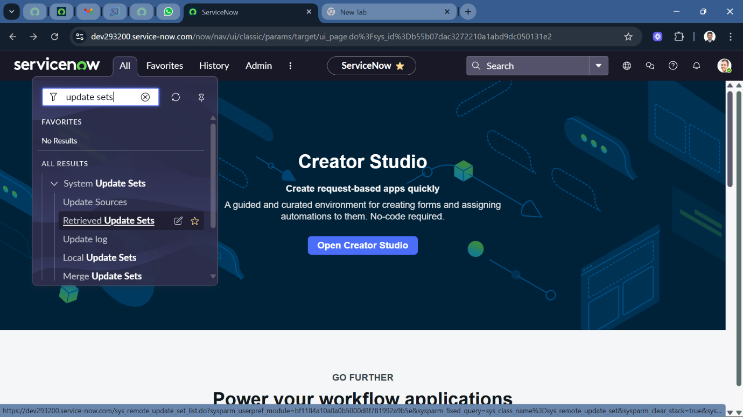

In this page, click “**Import Update Set from XML**” in the bottom left corner.

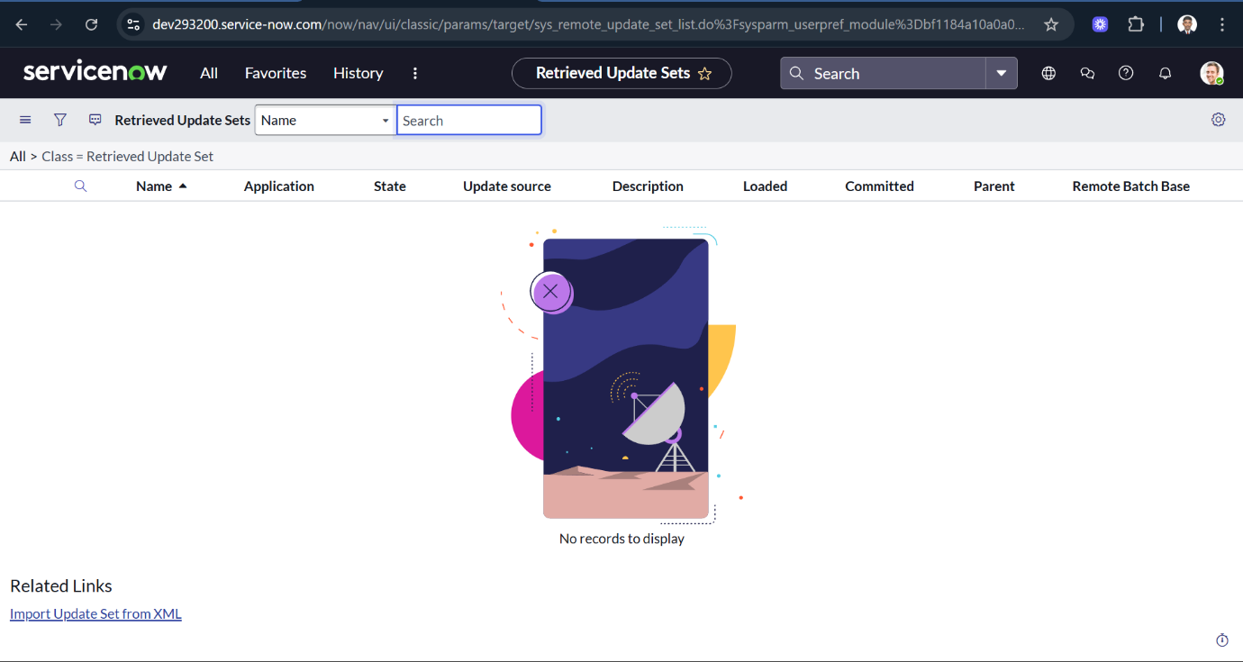

Upload the previously downloaded XML file in this page and click “**Upload**” button

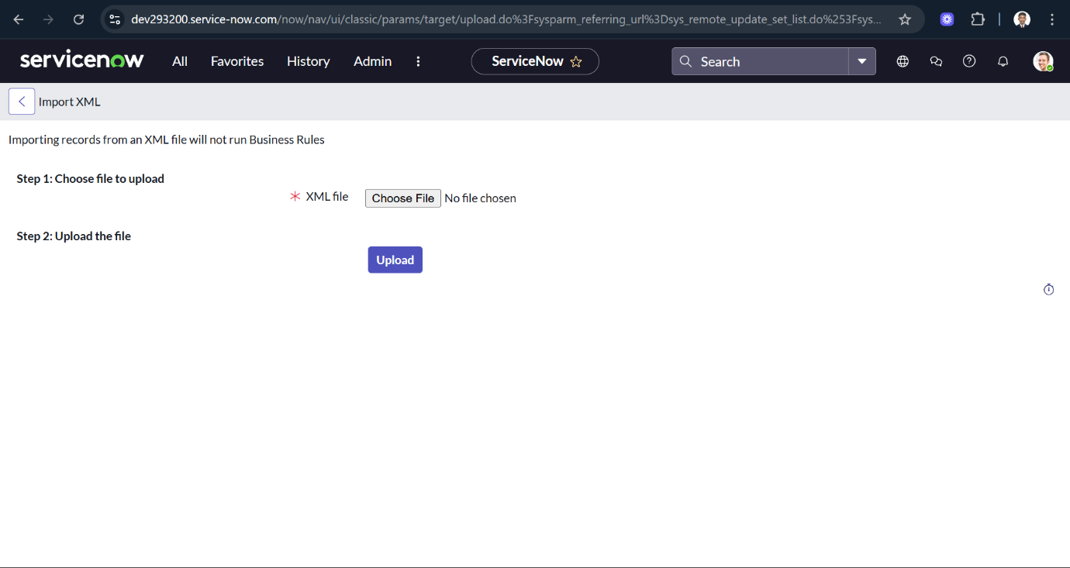

Open the **Retrieved Update Set** named **“Laptop Request Project”**

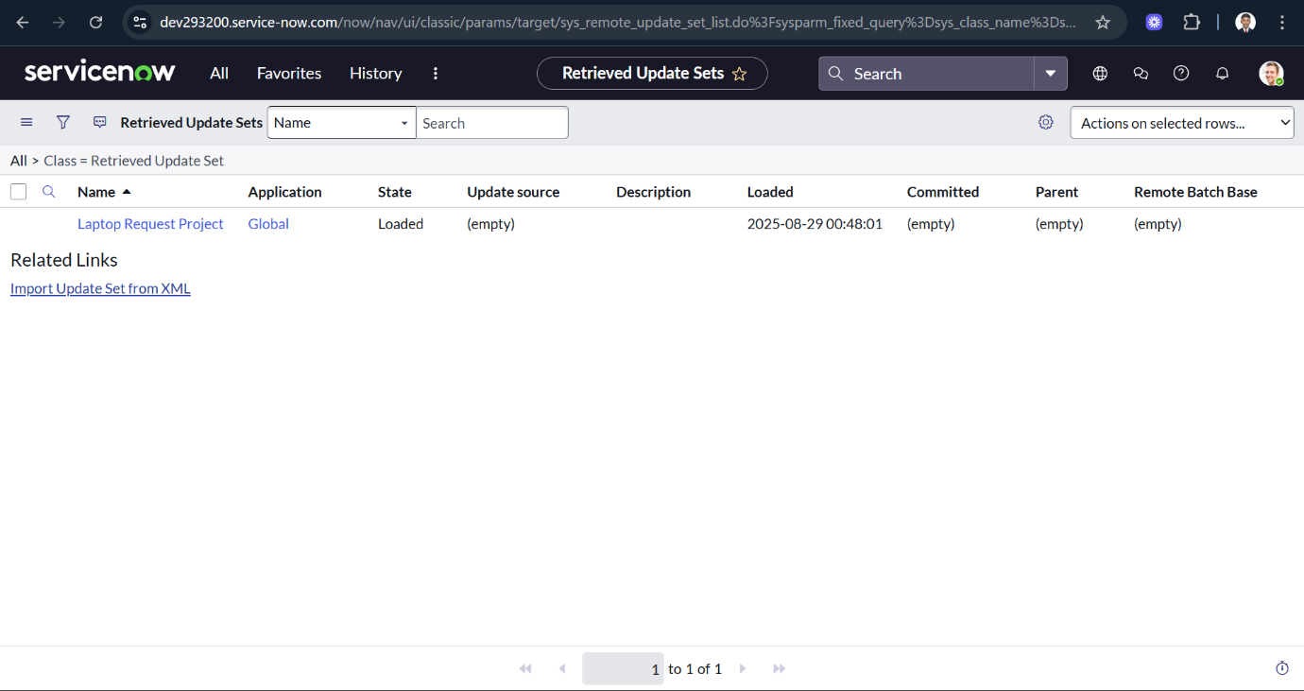

Click **Preview Update Set** to review the changes.

After verifying, click **Commit Update Set** to apply the updates.

You can also review all captured changes in the **Updates** related tab.

Once the update set is committed, all changes from the previous instance will be applied to the current instance.

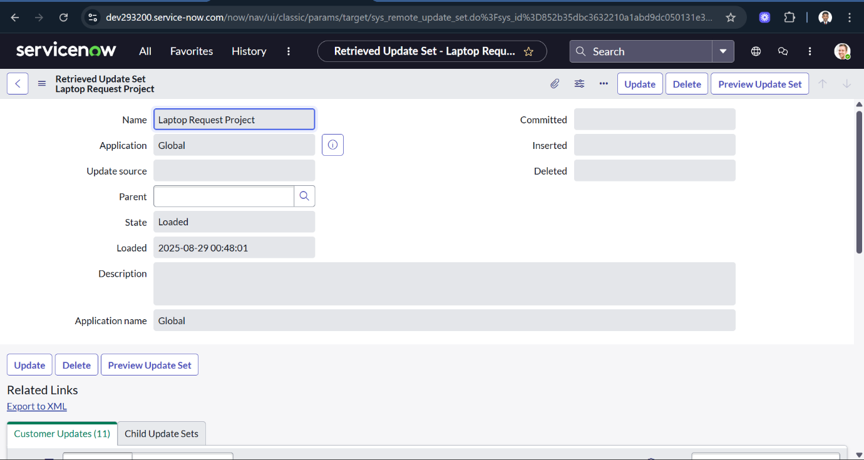

**Testing**

**Test Catalog Item:**

In the target instance, search for **Service Catalog** in the application navigator.

Under **Service Catalog**, select **Catalog**.

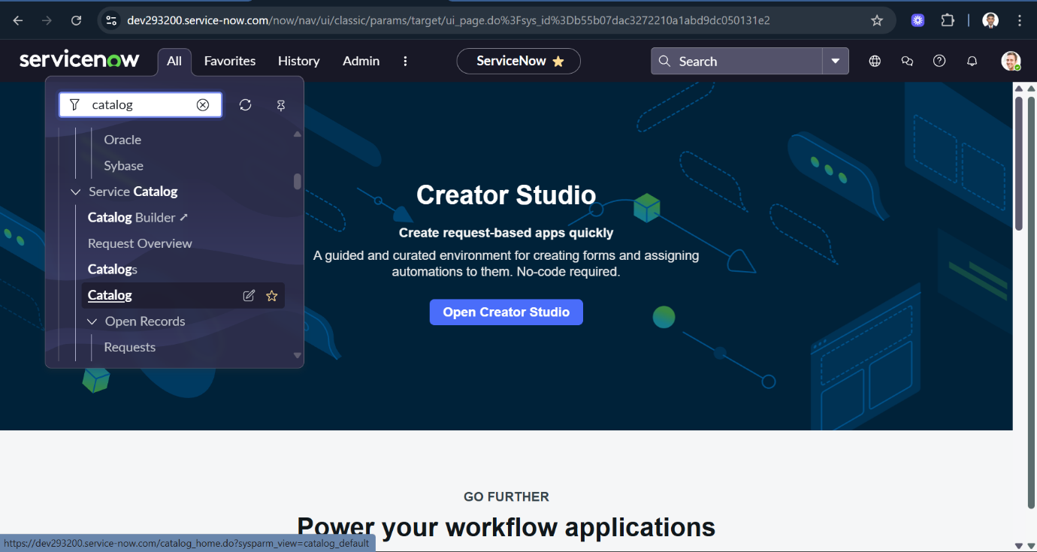

Choose the **Hardware** category.

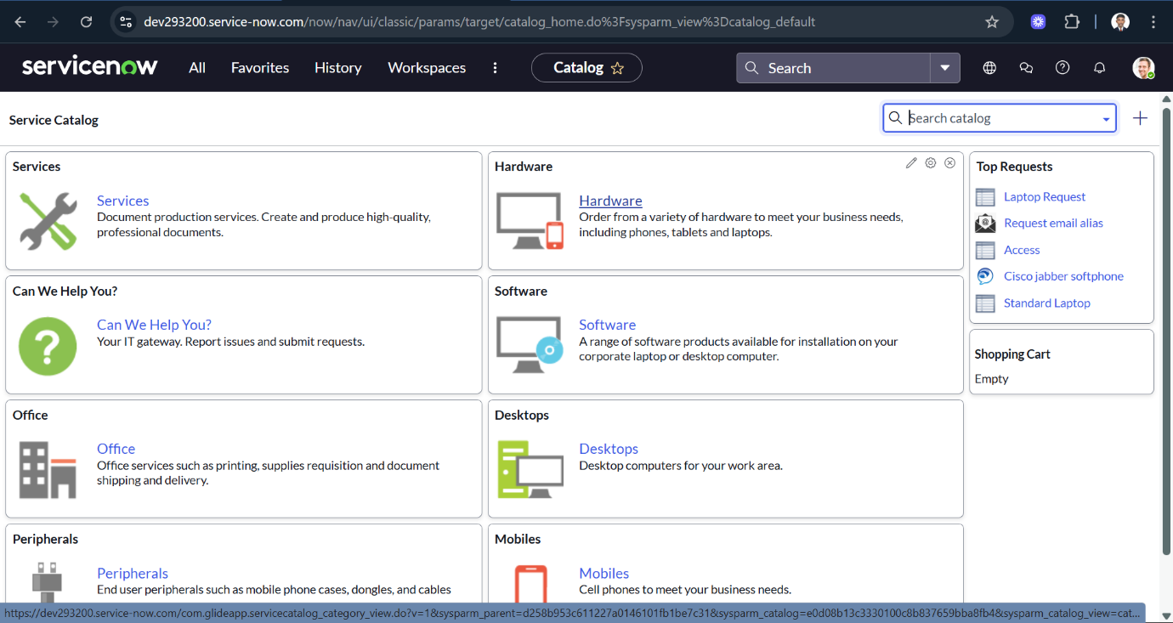

Search for the **“Laptop Request”** item in the **Hardware** category.

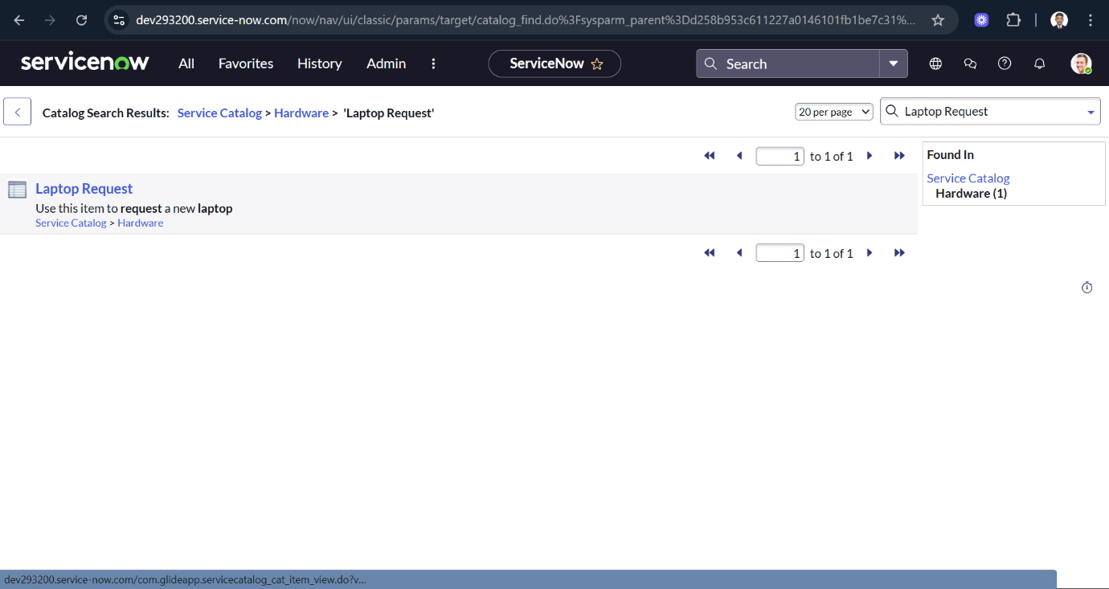

Open the **Laptop Request** catalog item.

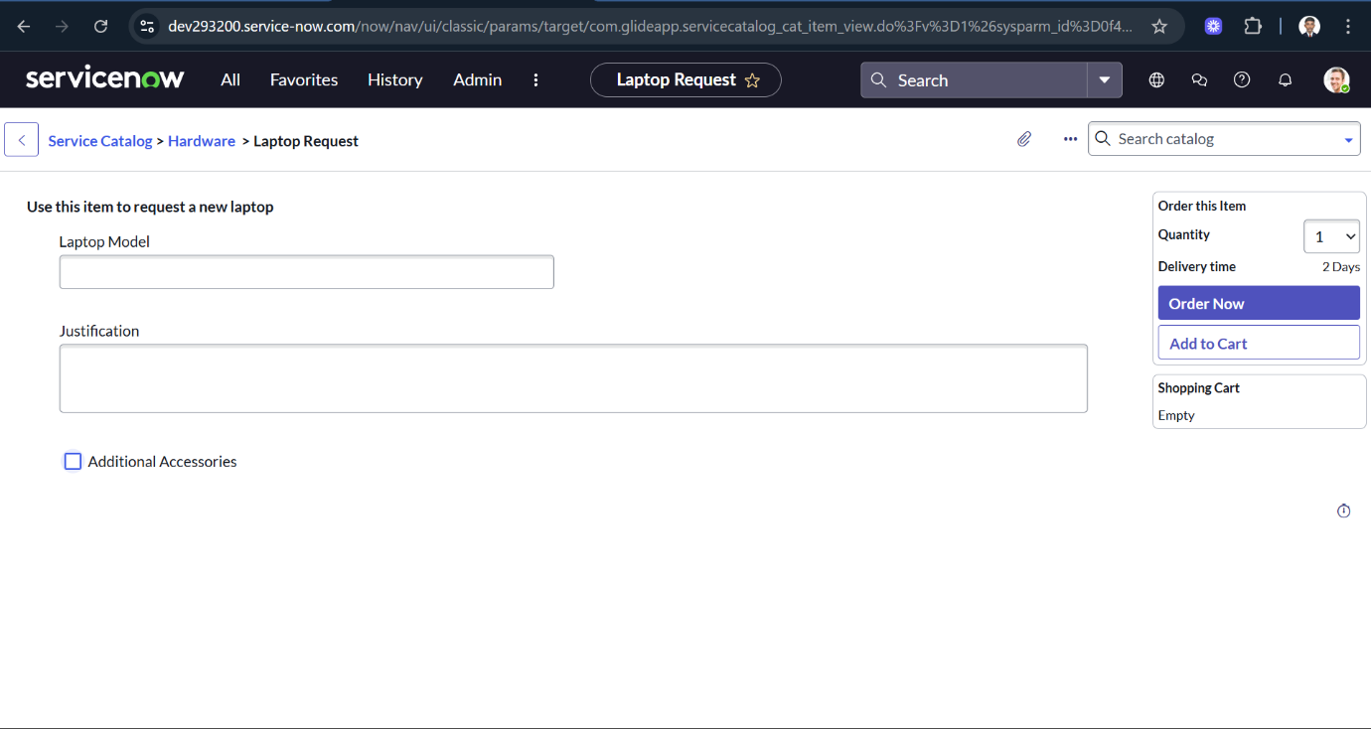

In our scenario, when the **Additional Accessories** checkbox is selected, the **Accessories Details** field becomes visible and is set as mandatory. Upon testing, the functionality works as expected and meets all the specified requirements.

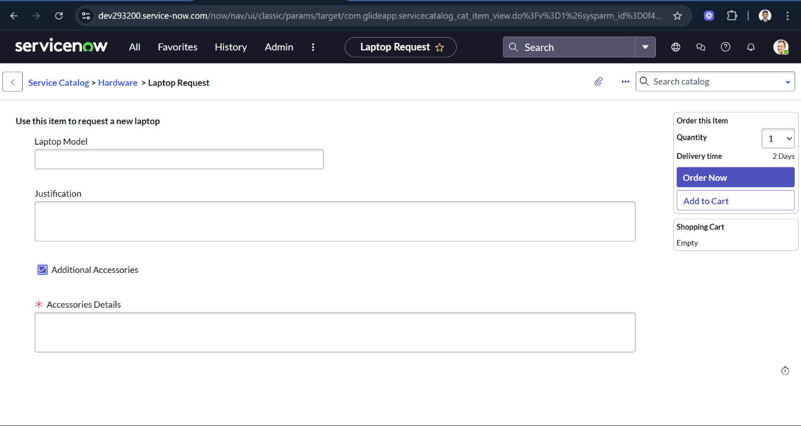

**Conclusion:**

In many organizations, the process of requesting laptops is still handled through **manual methods** such as emails, paper forms, or verbal communication. This creates inefficiencies, as employees often fail to provide complete information, leading to back-and-forth clarifications with IT staff. Such delays affect productivity, especially for new employees waiting for their laptops to start work.

The **approval process** is another challenge in the traditional system. Managers may overlook requests due to email overload, or approvals may take too long without proper tracking. This lack of structure can also lead to unauthorized or unnecessary requests being fulfilled, increasing costs and reducing accountability within the organization.

Additionally, there is a **lack of transparency** for employees once they submit a request. Without a centralized system, employees cannot track the progress of their laptop request and must repeatedly follow up with managers or IT staff. Similarly, IT teams face difficulty in monitoring and managing multiple requests without proper records. These challenges highlight the need for an **automated and structured request process** that ensures standardization, faster approvals, and complete visibility.